
OPERATIONAL LAUNCH PLAN
30-Day AI Marketing Campaign
Starting capital: PKR 30,000 | Karachi-first | WhatsApp Business | Solo founder

Executive Summary
AtoZ Online Mart will begin as a lean, WhatsApp-first general online mart serving Karachi. The business will resell a small selection of practical, compact products, validate demand with real customers, and reinvest only after tracking delivered orders and actual contribution. The first 30 days are a validation cycle, not a promise of sales or profit.
Business model | Buy small wholesale quantities and resell
Initial market | Karachi, Pakistan
Primary sales channel | WhatsApp Business; social content supports discovery
Initial product range | 5–8 SKUs across 3–5 practical product types
Total capital | PKR 30,000
Core principle | Protect cash, validate demand, track delivered-order profitability

Brand Foundation
Brand name: AtoZ Online Mart
Proposed tagline: “Smart Shopping, All in One Place.”
Brand personality: helpful, affordable, modern and trustworthy.
Brand promise: useful everyday products, convenient ordering and clear delivery information.
Brand note: check name availability across social platforms, domains and relevant business registration records before investing in branding or packaging.

1. Recommended Startup Budget
The following is a planning allocation, not a supplier quotation. Keep some money in reserve rather than committing all cash to inventory.
Budget item | PKR | Share
Initial inventory | 12,000 | 40.0%
Samples and sourcing travel | 2,000 | 6.7%
Packaging and labels | 1,500 | 5.0%
Marketing and advertising tests | 3,000 | 10.0%
Delivery and COD working cash | 3,000 | 10.0%
Emergency and replenishment reserve | 8,500 | 28.3%
TOTAL | 30,000 | 100%

Budget rules:
- Treat PKR 12,000 as an inventory ceiling, not a target that must be spent immediately.
- Release advertising funds in small tests only after the order process and margins are checked.
- Keep the PKR 8,500 reserve for justified replenishment or unexpected operating costs.
- This plan excludes a paid website, employee salaries, and any registration or tax costs that may apply.

2. Product Sourcing Plan
Start with three product types if supplier prices are high. These are test candidates, not verified bestsellers.
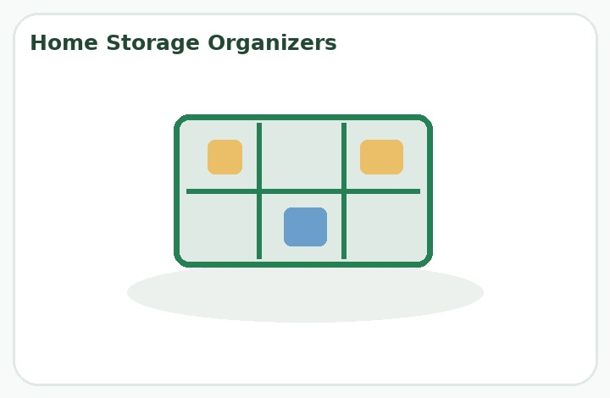
Home storage organizers
Drawer dividers and compact storage items; test 3–5 units.

Kitchen and cleaning accessories
Simple manual tools that are easy to inspect and demonstrate; test 3–5 units.
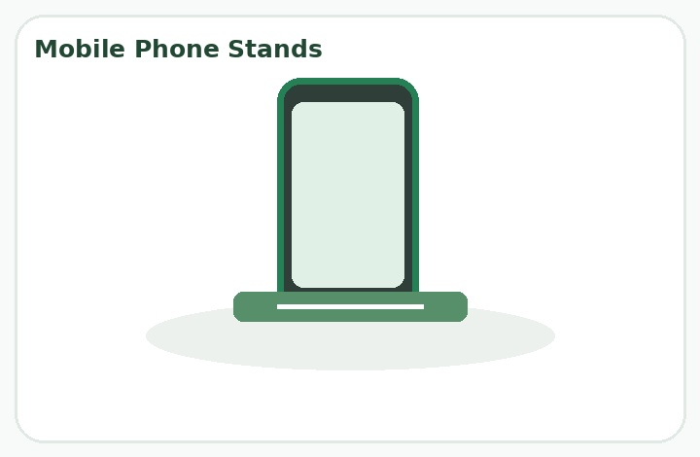
Mobile phone stands
Compact stands that are easy to show in short videos; test 3–5 units.
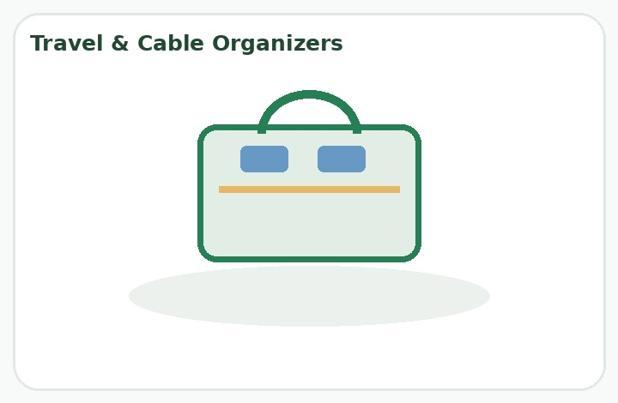
Travel and cable organizers
Lightweight pouches and organizers; test 3–5 units.
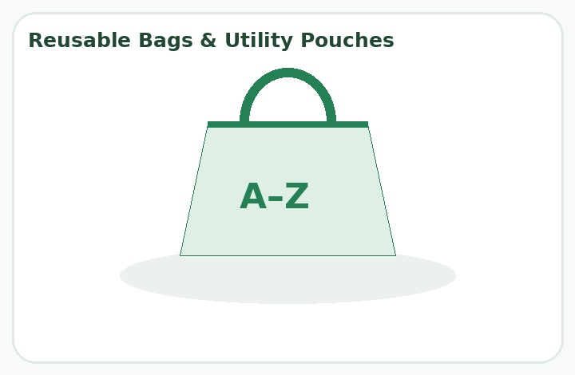
Reusable bags and utility pouches
Easy-to-store daily-use items; test 3–5 units.

Supplier sourcing options
- Explore Saddar wholesalers for simple mobile accessories; confirm exact shop location, stock and prices before travel.
- Compare local household-goods wholesalers for kitchen, cleaning and storage products.
- Contact online wholesale suppliers to compare prices before deciding whether an in-person visit is worthwhile.
- Ask at least three suppliers per shortlisted category for prices at 3, 5, 10 and 20 units, minimum order quantity, sample policy, defects/exchange policy, repeat availability, tax and transport costs.
- Inspect samples, obtain a receipt, and record supplier contact details. Avoid bulk purchases based only on a supplier's claim that an item is trending.

Supplier message template
Assalam-o-Alaikum. I am starting AtoZ Online Mart in Karachi and looking for wholesale products for resale. Please share wholesale prices for 5, 10 and 20 pieces, minimum order quantity, available colors/designs, quality details, and your defective-item return or exchange policy. Can I buy a few samples first and then place repeat orders if the products sell well? Please confirm shop location, payment terms and whether a receipt is provided. Thank you.

3. Pricing and Profit Control
Illustrative example only: mobile phone stand. Replace all figures with actual quotations.
Item | PKR
Wholesale cost | 250
Packaging | 25
Failed-delivery/return allowance | 40
Advertising cost per delivered order | 70
Total cost before delivery subsidy | 385
Illustrative selling price | 599
Contribution before other overheads | 214
Assumption: the customer pays delivery separately. If the seller subsidizes delivery, add that cost before calculating contribution. Taxes, sourcing transport and overheads may further reduce profit.
Pricing rule: compare competitor prices, product quality, customer willingness to pay and the full cost of completing a delivered order. Do not set prices using wholesale cost alone.

4. WhatsApp Business Setup
- Use a dedicated business number if possible.
- Set the name to AtoZ Online Mart; add a clear logo, short description and service hours.
- Upload 5–8 products with real photos, SKU codes, accurate descriptions and prices.
- Create labels: New Inquiry, Order Pending, Confirmed, Dispatched, Delivered and Returned.
- Set greeting, away message and quick replies for frequently asked questions.
- Share the catalog link through social profiles and relevant customer conversations.

Welcome message template
Assalam-o-Alaikum! Welcome to AtoZ Online Mart. Thank you for contacting us. We offer useful everyday products at competitive prices. Please tell us which product you are interested in, and we will share its price, availability and delivery details. Karachi delivery: ask us for available options and charges. Thank you for choosing AtoZ Online Mart!

5. Order Management Process
1. Inquiry received — Record customer contact, requested item and date.
2. Availability and price checked — Confirm stock, total price, delivery fee and realistic delivery estimate.
3. Order confirmed — Collect name, phone number, complete address and landmark.
4. Quality check and packing — Inspect the item, record SKU and package securely.
5. Courier booking — Record tracking number, courier charge, COD amount and dispatch date.
6. Delivery follow-up — Monitor tracking and contact the customer if delivery is delayed.
7. Settlement and profit — Reconcile courier remittance, delivered sales, returns and actual costs.

Order spreadsheet columns
Field | Example / note
Order ID | AZ001
Order date | Date placed
Product / SKU | STAND01
Quantity | Units
Product revenue | Actual amount
Delivery collected | Actual amount
Customer details | Store securely
Courier / tracking | Booking reference
Status | Confirmed / dispatched / delivered / returned
Product cost | Actual amount
Packaging and other costs | Actual amount
Advertising allocation | Actual or estimated
Courier settlement | Pending / received
Final contribution | Calculate after delivery and reconciliation
Privacy: collect only necessary customer information, restrict spreadsheet access and do not share addresses or phone numbers in public posts.

6. Courier and COD Precautions
- Compare at least two courier services for Karachi coverage, pickup availability, merchant rates and delivery timelines.
- Ask about COD remittance timing, failed-delivery/return-to-origin fees, weight slabs, taxes and claims for damaged shipments.
- A published Pakistan Post COD rate page has shown local tariffs of PKR 190 for 250 g and PKR 215 for 500 g; treat these only as a benchmark and confirm current applicable rates and merchant terms.
- Keep working cash available because shipping may be paid before COD proceeds are remitted.
- Confirm suspicious or unusually large orders before dispatching.
- Treat an order as a completed sale only after delivery and payment reconciliation.

7. Daily Founder Checklist

Morning — 20 minutes
- ☐ Check WhatsApp inquiries and pending orders
- ☐ Review inventory and dispatches
- ☐ Confirm orders awaiting customer details

Content — 30–45 minutes
- ☐ Publish or schedule one useful product post or short video
- ☐ Share a WhatsApp Status featuring an available product
- ☐ Reply to questions and record customer objections

Operations — 30 minutes
- ☐ Inspect and pack confirmed orders
- ☐ Update order sheet and tracking details
- ☐ Follow up on delayed deliveries or pending settlements

Evening — 10–15 minutes
- ☐ Record inquiries, orders, ad spend and delivered sales
- ☐ Review content that generated useful conversations
- ☐ Choose tomorrow's main task
Expected routine: about 1.5–2 hours on a normal day, excluding sourcing visits, busy order periods and delivery issues.

8. 30-Day Operational Schedule

Days 1–3 | Research before spending
- Define brand name, logo concept and product criteria.
- Contact at least three suppliers and compare prices.
- Create order and expense spreadsheets.
Deliverable: shortlist of 5–8 products with comparable supplier prices.

Days 4–7 | Inspect and prepare
- Buy samples or small quantities and test quality.
- Calculate margins and buy only controlled initial stock.
- Set up WhatsApp Business and product listings.
Deliverable: catalog, prices and order procedure ready.

Days 8–14 | Organic launch
- Publish brand introduction and product demonstrations.
- Share catalog links and WhatsApp Status updates.
- Record inquiries, orders and customer objections.
Deliverable: first demand signals and a working order process.

Days 15–21 | Test offers and advertising
- Identify products generating qualified inquiries.
- Test video hooks and captions.
- Run a small ad test only if margins and fulfillment are ready.
- Monitor delivery and failed COD orders.
Deliverable: evidence about products and messages worth testing further.

Days 22–30 | Review and improve
- Calculate contribution from completed orders.
- Compare advertising cost with delivered sales.
- Replenish only proven products.
- Prepare a month-two plan based on actual evidence.
Deliverable: decision to continue, improve or discontinue each product test.

9. 30-Day Content Calendar
Day | Theme | Format | Brief
1 | Brand introduction | Short video | Introduce AtoZ Online Mart and its mission.
2 | Product teaser | Carousel | Show three useful products; ask which is most useful.
3 | Problem and solution | Reel | Demonstrate a real use case.
4 | Product spotlight | Photo | Show actual price, features and ordering details.
5 | Behind the scenes | Video | Show sample inspection or packaging.
6 | Shopping tips | Carousel | Share practical buying tips.
7 | Audience questions | Stories | Ask what matters most: price, quality or delivery.
8 | Product demonstration | Reel | Show how one product works.
9 | Benefits explained | Carousel | Explain three verified benefits.
10 | FAQ | Stories | Answer price, stock, payment and delivery questions.
11 | Product comparison | Video | Compare two options fairly.
12 | Bundle idea | Image | Show a bundle if margins support it.
13 | Founder story | Video | Explain why the business started.
14 | Weekly recap | Carousel | Recap featured products and invite questions.
15 | Top-interest product | Reel | Feature the product with strongest qualified interest.
16 | Use case | Video | Show the item in an everyday setting.
17 | Offer test | Image | Test a genuine offer with clear conditions.
18 | Trust-building | Graphic | Explain order confirmation and support process.
19 | Product FAQ | Carousel | Clarify dimensions, material or compatibility.
20 | Customer feedback | Post | Share genuine feedback only with permission.
21 | Campaign reminder | Stories | Remind viewers about product and ordering.
22 | Best creative | Reel | Rework the strongest opening hook.
23 | Objection handling | Carousel | Address real concerns about price and delivery.
24 | Product bundle | Video | Demonstrate complementary products.
25 | Shopping guide | Carousel | Help customers choose the right option.
26 | Q&A | Stories/live | Answer questions and demonstrate products.
27 | Product reminder | Video | Show a feature and clear call to action.
28 | Month highlights | Carousel | Share real content and business milestones.
29 | Customer service | Graphic | Explain how to get order updates and support.
30 | Month-end review | Internal report | Review sales, inquiries, delivery, costs and next steps.

10. AI Prompts for Daily Use

Product research
Act as an e-commerce product researcher for AtoZ Online Mart in Pakistan. Suggest practical products for a small general online mart. Evaluate use cases, competition, supplier reliability, shipping practicality, quality risks and potential margins. Separate assumptions from verified findings and provide a validation checklist.

Social content
Act as my AI social media manager. Create seven days of Facebook, Instagram and TikTok content for AtoZ Online Mart. For each day provide a hook, video or image concept, caption, call to action, hashtags and image-generation prompt. Use natural Pakistani English and optional Roman Urdu. Do not invent prices, discounts, testimonials or features.

Advertising
Act as a performance marketing specialist. Develop a small-budget Meta Ads test for AtoZ Online Mart in Pakistan. Recommend objective, audience hypotheses, creative variations, budget allocation, tracking, measurement window and pause/scale rules. Use actual product margins; do not guarantee sales or ROAS.

Sales analysis
Act as my e-commerce business analyst. Review AtoZ Online Mart sales and advertising data. Calculate contribution per delivered order, advertising cost per delivered order, ROAS, cancellation rate and return-to-origin rate where data permits. Identify missing data and three practical improvements. Never treat unconfirmed orders as delivered sales.

11. KPIs and Formulas
Metric | Purpose / formula
Reach and video views | Measure content discovery.
Qualified inquiries | People showing real buying interest.
Inquiry-to-order rate | Orders ÷ qualified inquiries × 100.
Delivery success rate | Delivered orders ÷ dispatched orders × 100.
Cost per delivered order | Advertising spend ÷ delivered orders attributed to ads.
ROAS | Revenue attributed to ads ÷ ad spend.
Contribution per delivered order | Revenue minus all variable costs for the completed order.
Return-to-origin rate | Returned-to-origin shipments ÷ dispatched shipments × 100.
Do not judge success by followers, likes or revenue alone. Orders must be delivered and payments reconciled; account for returns and all variable costs.

12. Assumptions and Unknown Costs
Supplier pricing and minimum quantities: Unknown until current quotations are obtained; determines actual stock quantity.
Courier and failed-delivery charges: Merchant rates, pickup fees, COD settlement timing and return-to-origin costs are unconfirmed.
Advertising performance: Acquisition cost, conversion rate and sales volume are unknown until campaigns run.
Tax and business compliance: Registration, tax, invoicing and consumer-policy requirements depend on the business setup; verify with relevant Pakistani authorities or a qualified adviser.
Storage, returns and damaged stock: Assumes home storage is available; damage, refunds, replacement stock and packaging may need extra cash.
Website and staff: Not included in this lean budget.

13. Immediate Next Steps: First 48 Hours
- List 10 candidate products from the categories in this plan.
- Contact at least three suppliers and collect written quotations.
- Compare landed cost, likely selling price and delivery expenses.
- Select no more than three product types for the first stock purchase.
- Create the WhatsApp Business profile and order-tracking spreadsheet.
Final recommendation: Keep cash flexible. The first objective is to discover which products Karachi customers will actually buy at a profitable price—not to build a large inventory or spend heavily on advertising.

Reference and verification notes
This document is an operational planning guide. Product categories, sample budgets and example margins are illustrative. Confirm supplier quotations, current courier tariffs, COD merchant terms, platform policies and applicable Pakistani legal/tax obligations before acting. No sales, advertising performance or profitability outcomes are guaranteed.

